Description of contents 28 Nov 24
This temporary folder contains scripts and data derived from the raw (EDM) spill data provided by Environment Agency.
- Raw data binded (all wascs (exl. Hafren Dyfrdwy) & years) [“raw_spill.RData”]
This data is the merging of all the raw spill data provided – the associated script can be found as “extension all wasc raw spill data binding.R” – involves declaration of date/time objects for analysis – and deals with missing values caused by daylight savings time changes (in late March when DST starts, the time 1AM to 2AM does not exist on one day – so raw spill times given in this period are not real times, for these I added 1 hour, under the assumption the EDM had not adjusted it’s time for daylight savings yet)

- EA Consents Data ["Consented Discharges to Controlled Waters with Conditions.accdb"]
This data is sourced from https://www.data.gov.uk/dataset/55b8eaa8-60df-48a8-929a-060891b7a109/consented-discharges-to-controlled-waters-with-conditions
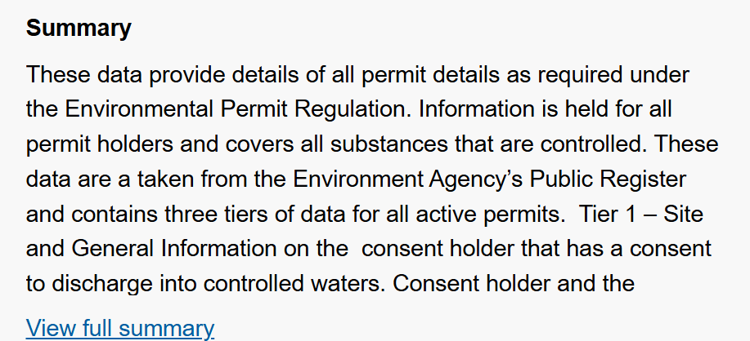

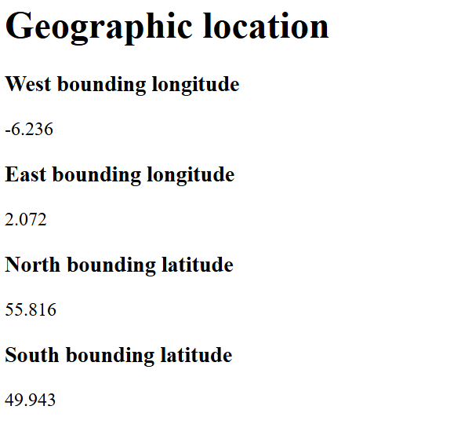
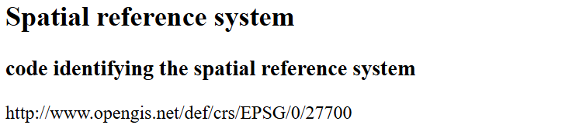
Metadata available here: https://ckan.publishing.service.gov.uk/harvest/object/373b566f-2b0d-45c2-a854-90c188344233/html . Importantly, this data provides the location of each discharge site – as postcode and as a geospatial reference to high precision in OS National Grid Format (also included are receiving waterbody & type)

- Anglian water raw data merged with EA consents data [“anglianmatched.RData”]
This is the raw data for Anglian Water – matched with the relevant information from the EA consents database. Anglian Water is unlike the other WaSCs as for 2021 and 2022 they provided the EA Permit Reference for each of their discharges. For 2023 data and for the other WaSCs, matching via given site names is required.
Matching of the site names required string cleaning then exact matching (matched some), fuzzy matching (matched others), matching via a third dataset (2023 EDM returns) which matched some of the remaining data, and some manual matching. The script used is provided as “anglian raw spill consents merging v3.R” and a similar process is being taken with the other WaSCs
There were cases where permit number and/or site name corresponded to several entries in the EA consents database – so this data was arranged by issue date (when the permit was approved) and the most recent entry was taken
- 12 24 Spill Tools [12 24 with DST changes v2.R]
This R script includes two functions that together convert raw spill data into the 12 24 spill method as defined by Ofwat. The first has been successfully adjusted to deal with daylight savings change causing edge cases, and the second is being modified – although no edge cases relevant to the second function appeared in Anglian’s data (several involving the first function did)
https://www.ofwat.gov.uk/wp-content/uploads/2023/05/Storm-overflows-PC-definition.pdf
- Anglian clean data [anglianclean.RData]
This data is the cleaned data for Anglian water, containing all relevant columns, and having been transformed according to the 12 24 spill count methodology. Other data will be provided shortly

